WEB BASED CONTROL LABORATORY

1.Applicants: Leyla Özkan, Siep Weiland*, Roland Toth*, A.C.P.M. Backx*, Peter Janssens, Ivo Roghair‡

Background and Motivation
This proposal aims to change the whole basis of laboratory experimentation both to be more engaging to digitally literate students and to maximize the efficiency of limited resources as the university grows.

The department of EE faces a substantial increase in the number of students. This puts stress on available equipment, available staff and lab space to carry out practical assignments in an educationally optimal manner, more specifically on laboratory setups that are made accessible as part of OGO projects, lab sessions and project assignments.

With the growing number of students, providing hands on experience within the official working hours and limited lab space is challenging. Moreover, EE department also offers courses to students from other departments. An example is the course of Dynamics and Control of Processes (6E8X0). Currently, including lab experiments in the course of 6E8X0 is out of question. Furthermore, as EE department, it is not feasible to accommodate certain lab set-ups due to lack of required safety infrastructure in the labs. In order to address such challenges we will develop a web based control laboratory. We believe that this not only provides more efficiency in the teaching process and allows more students to experiment but also provides a novel and more interesting technical interaction.

Project Description
We propose to develop internet based remote laboratory experiments in order to

- provide students the flexibility of executing experiments anytime and anywhere at TU/e.
- provide instructors/groups with limited lab space the flexibility of accommodating larger number of students than physically possible in the lab rooms
- provide instructors/groups flexibility to have access to lab setups in other departments/universities.
- provide techniques for remote control of the equipment

For demonstration purposes, we will make two specific experimental set-ups available outside the laboratory.

The Control Systems Group at the EE Department owns a Three-Tank System that is mainly used in control relevant master courses, specifically 5SC26 Integration Course of Systems and Control Masters of which 45 students have enrolled this academic year. This is almost double the number of students (27) of last year. The system is used for identification, modeling, control, analysis and demonstrations. In addition, chemical engineering students in the course of Dynamics and Control of Processes 6E8X0 are given a project based on the data collected from this set up. It is not feasible for these students to perform the experiments themselves due to limited space in the lab. Recently, the group has acquired a distillation column. Extension of the environment to a distillation process works in the same fashion and is also foreseen in this proposal.

A representative sketch of the system overview for a three-tank system as a physical setup is shown in the following figure.

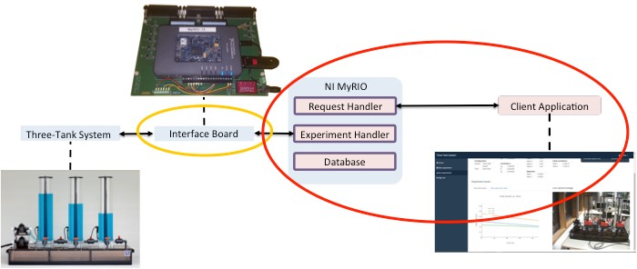

To allow web-based access this system needs to be extended with

- Interface Board: Maps the signals from the physical set-up to the signals in software environment.
- Processor: Real time platform that runs the control strategy
- Camera: Visualizes experiments
- Server Application: Is required for the clients to log in to the system, send HTTP requests, queues the experiments. It also stores the measurement data.
- Client Application: is the GUI where the clients can specify the experiments, observe the outcome of the experiments they run.

Project Structure and Plan

Work Package 1: Enhancement of Physical Set-ups (1 month): Three tank system and the distillation column need to be supported by hardware components to be remotely accessible. Depending on the number of signals and the frequency of the measurement data, an appropriate processor and an interface board will be selected and developed accordingly.

Work package 2: Development of Server and Client Application (2 months): Server and Client applications are software components of the project. Server Application is a generic component. With this component, the username and password will be assigned to each group and queuing of experiments is arranged. This application also features password assignment, reset and login information. On the other hand, the client application is experiment dependent and consists of the development of graphical user interface, the representation of the experimental data.
One of the important actions in this work package is the stress testing of the software environment.

Work Package 3: Development of Educational Approach (2 months): This work package will concentrate on developing generic guidelines that can be followed by others who want to integrate web based experiments in education. These guidelines will consists of : i) how to make proper assignments ii) how to design the user interaction, iii) how to adjust course plan and course material. For example, we may need to dedicate a lecture hour to demonstrate how the remote system works by using the remote lab in the classroom.

Work Package 4: Execution and Evaluation (6 months): Using the web based lab, the students will perform experiments and submit report(s). The remote lab gives flexibility to students to perform their experiments anytime. Nevertheless, in order to teach students scheduling of their work, the lab reports will have submission deadlines. Since the students are going to perform the experiments without the absence of the instructor and teaching assistants, we will use the new study guide Canvas to support the students via creating a discussion group.

In order to assess the learning experiences of the students, we will

- prepare technical and educational survey questions in the course evaluation
- form a focus group during the course and obtain their evaluation on software and hardware aspects of the project.

Based on the feedback by the focus group and the final survey, software refinement to improve the user interaction and educational material will be improved.

A tentative Gantt chart of the project is provided in the following.

Work%Packages%
Month%1
Month%2
Month%3
Month%4
Month%5
Month%6
Month%7
Month%8
Month%9
1
2
3
4

6. Deliverables and Utilization:

Deliverable 1: A prototype of a server application:
The server application component of this project is generic hence it can be transferred within the TU/e to other departments.

Deliverable 2: A Project Report: The experience of the instructors and the students will be presented, course evaluation will be analyzed and future directions will be discussed.

Control Systems Group, Department of Electrical Engineering
Education Department, Department of Chemistry and Chemical Engineering ‡ Chemical Process Intensification (SPI), Multiphase Reactors (SMR) Department of Chemical Engineering and Chemistry

