TU/e Innovation Call

Educational Innovation Proposal — revised November, 2016
Even Up
Digital resources for students to keep pace
Laura Astola
Current affiliation: IMAG/e BMT TU/e

Background and motivation of the project
From the three great challenges listed in the innovation call: increasing student numbers, decreasing student-teacher ratio, and a more diverse student population, I want to address the third. I regularly encounter students who lack some basic background knowledge. Organizing separate regular sessions to these students is not sustainable. Such students can greatly profit from tailor-made digital material and feedback. Indeed, experts on blended learning advice to discuss high level material during the contact hours and to let students polish routine skills on a suitable digital platform. Simultaneously the more advanced students will benefit from less pressure on basic topics.
The goal is to guarantee a sufficient level of the mathematical skills that are necessary in a particular engineering discipline (in this case medical image processing and analysis). It turns out that in image analysis precisely the lack of such skills is most often forming the obstacle for the students to pass the courses. For example, in the case of Fourier transform (besides physics and mathematics also important in electrical, biomedical, and mechanical engineering) this may concern lacking the concepts regarding complex numbers and trigonometry. More generally it may concern the ability of interpreting, e.g., summation/integral symbols, that is, the ability of reading and writing concise information in a compact and unambiguous form.
Fortunately, much of the material covering the mathematics that is necessary for the more applied disciplines has been already/is to be worked out in form of digital (Oncourse) exercises at the department of mathematics (dr. Hans Cuypers et al.). The challenge in practice is to link the courses of (in this particular project) medical image analysis to the set of matching exercises. Simultaneously this serves as a feedback for the mathematics department on how exactly the mathematical tools are applied in the discipline of medical image analysis and what skills are most relevant for this particular group.

Project platform and target students
The practical means we want to apply to unify the learning capacities is to develop and integrate digital material by exploiting the resources in CANVAS and Oncourse.
The target students are the bachelor students of the department of Biomedical Engineering. The platform will be the two existing courses “Images” (8DB00), which is obligatory to all second year students of BMT and the “Medical Image Analysis” (8DC00) for the third year students.
The students will be given weekly digital exercises in CANVAS to test their progress with the topics. For those exercises that involve the usage of mathematical tools the students will be linked to the matching Oncourse material that covers the theory and practice that is necessary to complete the exercise.

Relevant course modules in 8DB00
A student who is lagging behind is typically either not investing enough time on the course or is simply missing/has forgotten certain knowhow in basic mathematics. In the course “Images”, these are particularly manifested in the following topics:
Application: greyvalue remappings;
Necessary skills: Basic manipulation of equations, setting up and solving of linear equations, elementwise matrix operations;
1
Application: image filtering;
Necessary skills: Integration, convolution, inner products;
Application: image filtering in frequency domain;
Necessary skills: complex numbers, Fourier transform, linear algebra;
Application: morphological operations;
Necessary skills: elementary set theoretical and logical operations;
Application: image segmentation;
Necessary skills: basic optimization techniques;

Extension to course 8DC00
The plan is to apply similar linkage to the digital selfstudy material of the elective course 8DC00. Since 8DC00 assumes the students to have already completed 8DB00 and mastered the related mathematics, it is even more important that the students can update their skills according to the individual needs. This course also typically attracts foreign students and exercises that are carefully linked to the background material with which to practice may suffice for homologation. Similar to the course 8DB00, an inventory of the necessary topics will be made and the related mathematical techniques will be identified to link them to matching study material.

Collaboration with the department of mathematics and computer science
The applicant is in contact with dr. Hans Cuypers at the group at the department of Mathematics and Information Science to discuss the contents as well as the technical details linking the existing study material on mathematics in Oncourse to the digital material of 8DB00/8DC00. Naturally this will be of mutual interest since part of the exercises can be also tailor made in a fashion that suites the applications in biomedical engineering.
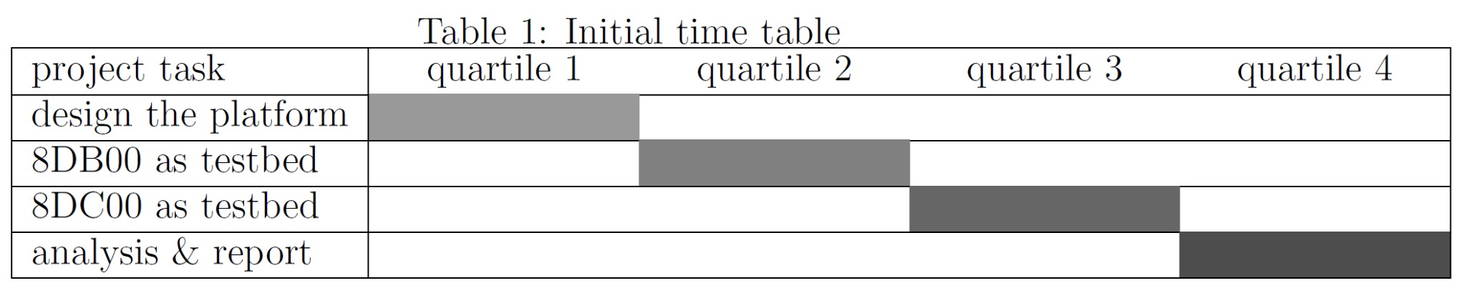

Objectives and expected outcomes of the project
The basic objective of this project is to test whether the existing digital resources can be effectively exploited to address the heterogenous backgrounds of the students. The outcome will be:
- a report on how the digital components and the cross-linking were designed and implemented;
- the statistics and an analysis of the actual students usage of the service and the relation to the learning results;
- an outlook of whether similar approach could be beneficial also for the whole line of studies of the IMAG/e group. This could be a very useful extension, since the master courses are given by the academic staff who experience a lot of pressure from other duties than education;
2

